IMPLEMENTING CRM FOR RESULT TRACKING OF A CANDIDATE WITH INTERNAL MARKS

Project Report Template

**INTRODUCTION**

Administrator should be able to create all base data including Semester, Candidate, Course and Lecturer, Lecturer

Should have the ability to create Internal Results, Dean, who is one of the Lecturer, should be the only one with ability to update Internal

Results, Re-evaluation Can be initialised by Candidate for all Internal

Results. Now only dean can update the marks after re-evaluation.

Salesforce is your customer success platform, designed to help you

Sell Service, market, analyze, and connect with your customer.

Salesforce has everything you need to run your business from anywhere. Using standard products and features, you can manage relationships with prospects and customers, collaborate and engage with employees and Partners, and store your date securely in the cloud.

**Problem Definition & Design Thinking**

**Empathy Map**

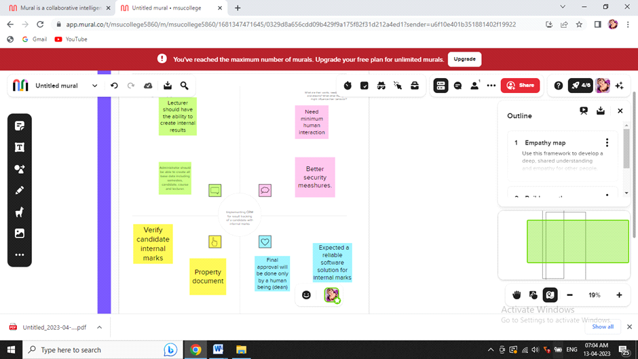

**Ideation & Brainstorming Map**

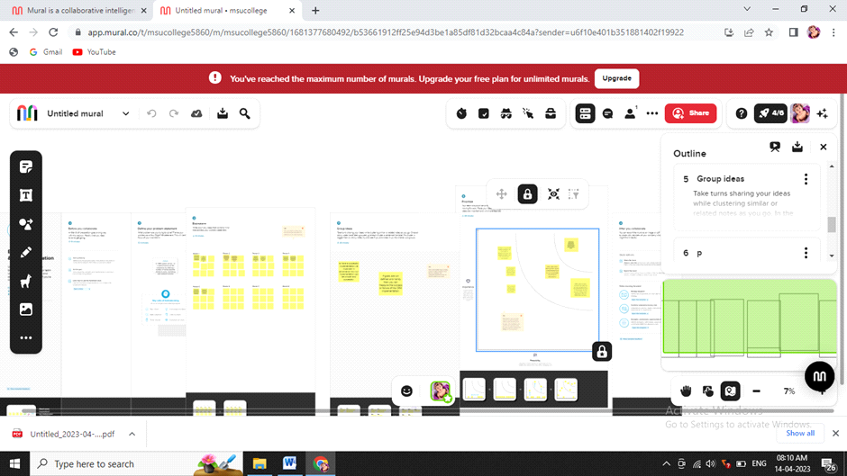

**RESULT**

**Data Model**

|  |  |
| --- | --- |
| **Object name** | **Fields in the object** |
| **semester** | **Field label:**  Semester name course  **Data type:**  text |
| **candidate** | **Field label:**  Candidate name  Candidate id  Semester name  Internal results  **Data type**  text |
| **Course details**  **Lecturer details** | **Field label:**  Course name  Course id  **Data type**  text  **field label:**  lecturer role  lecturer name  course id  course  **data type**  text |
| **Internal results** | **Field label:**  Candidate id  Course id    **Data type**  Text |

**Activity & screenshot**

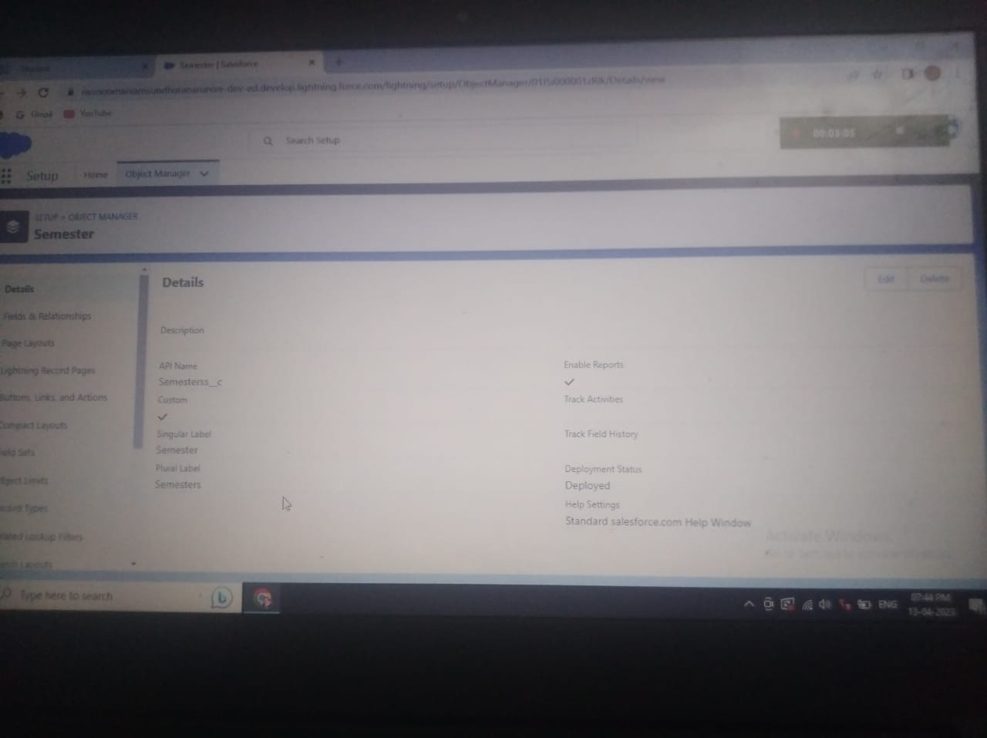

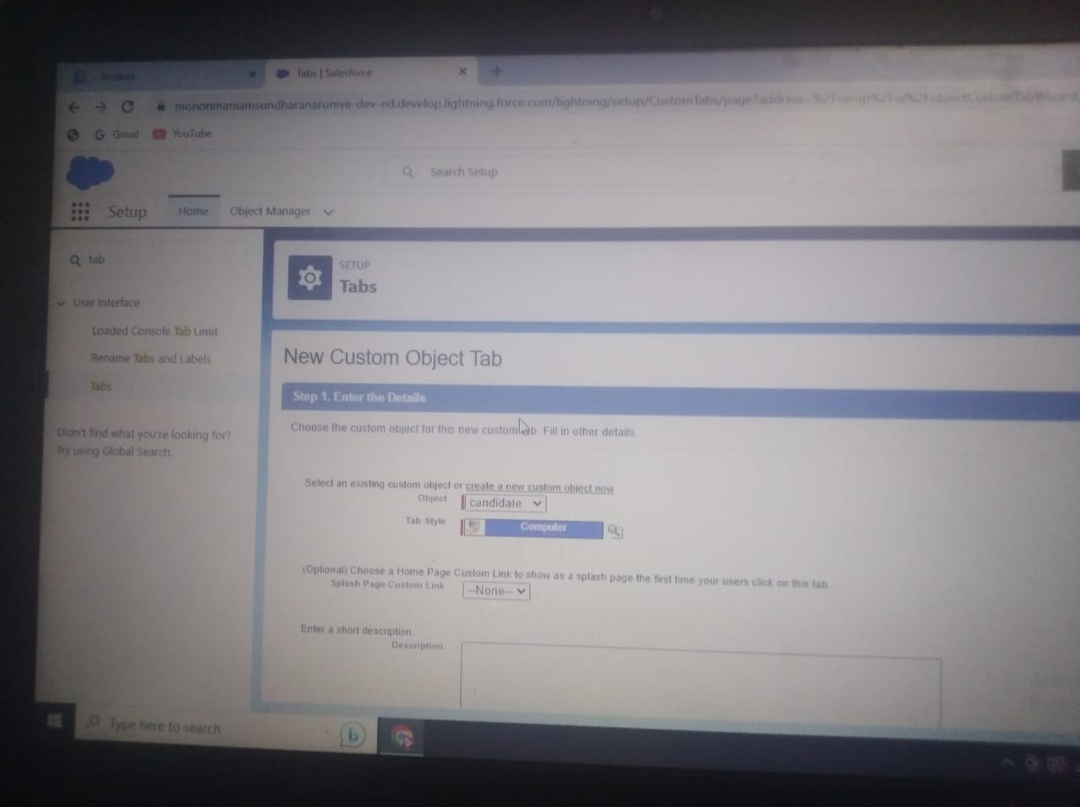

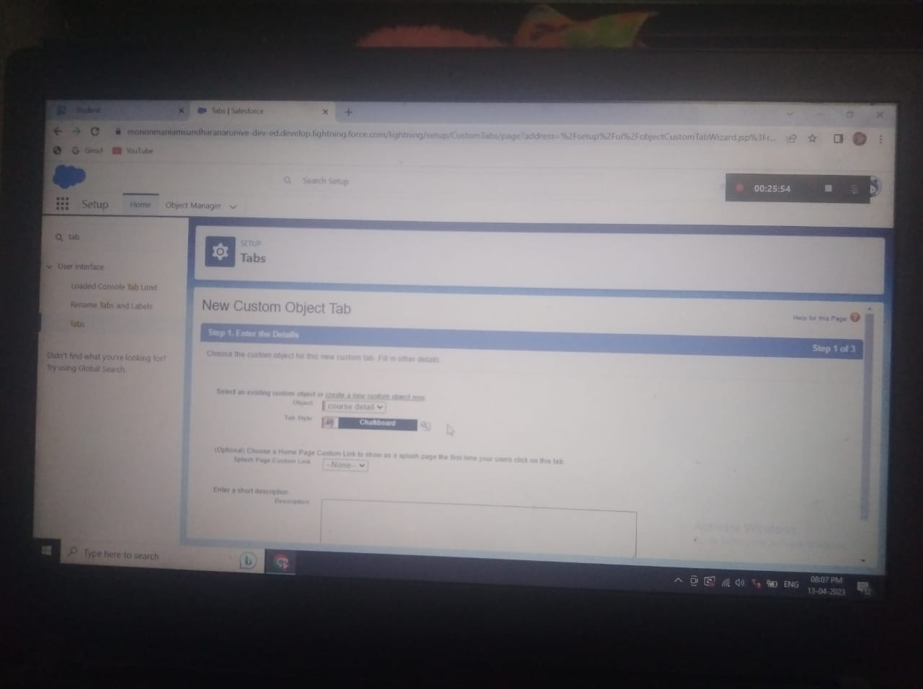

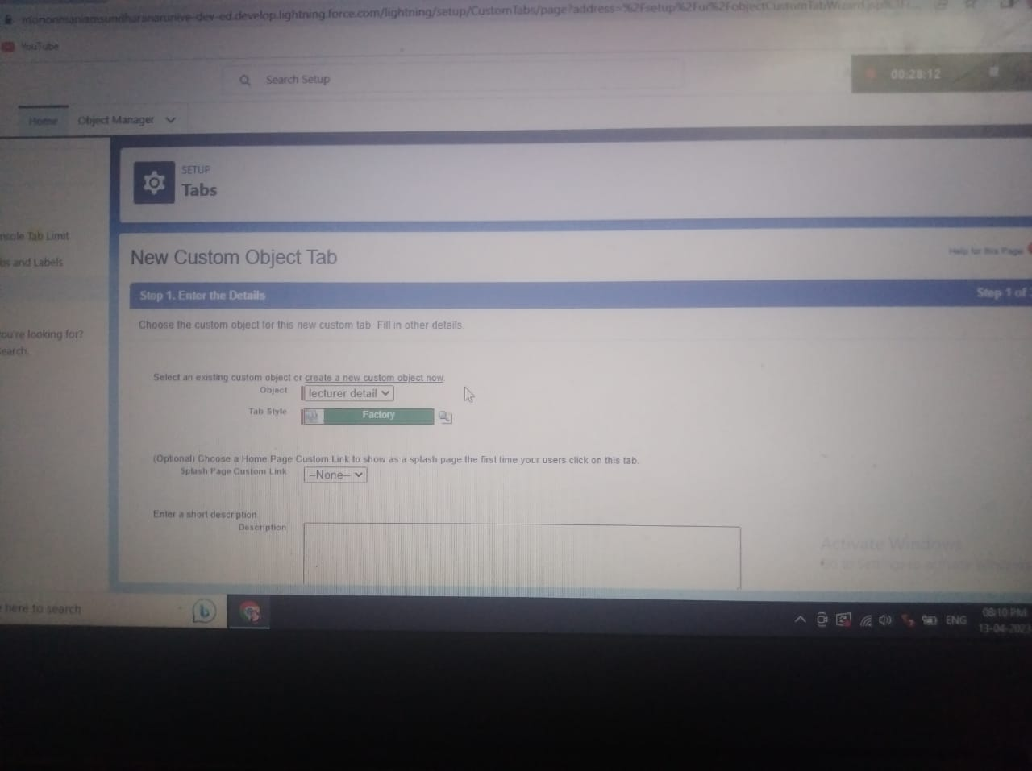

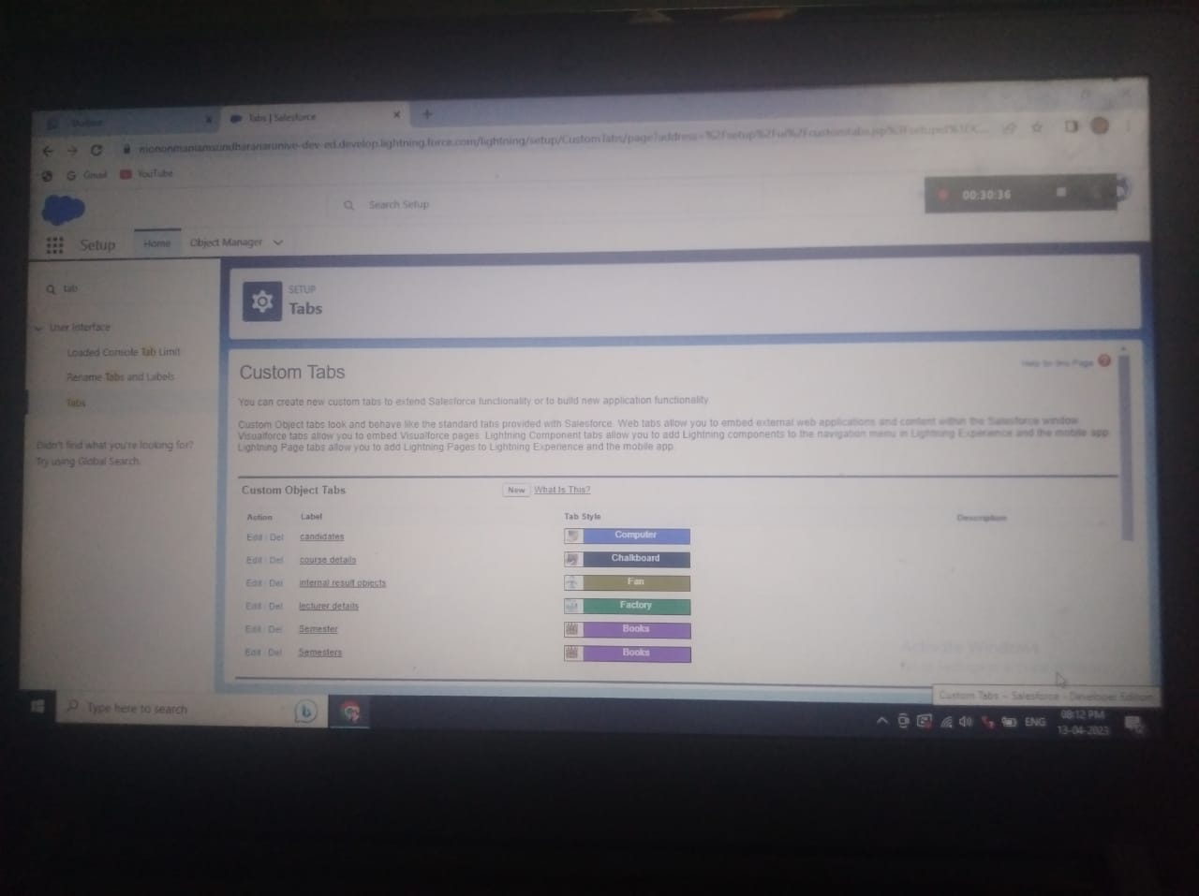

Fields & Relationship

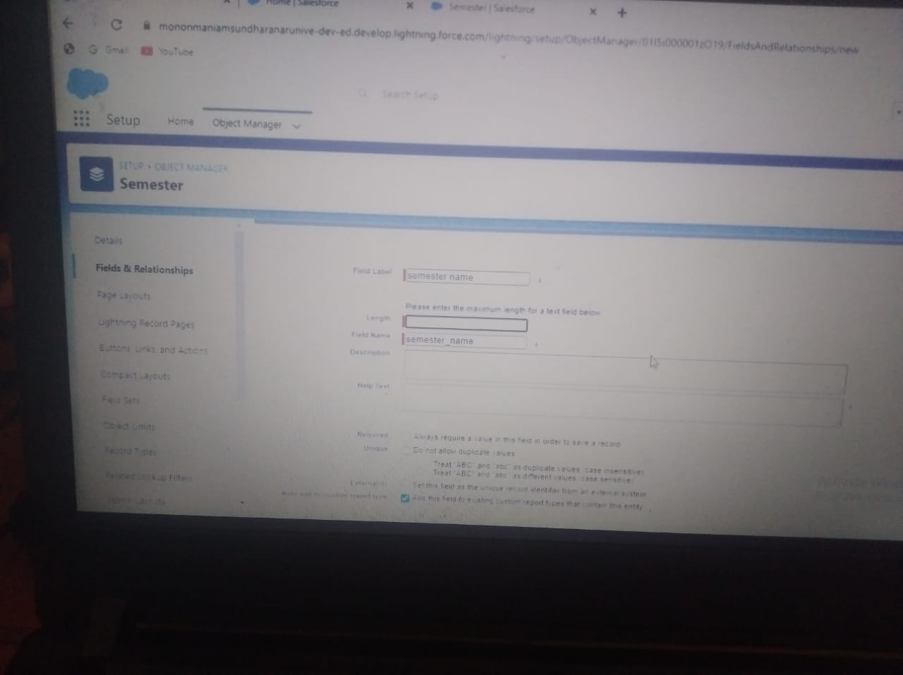

**Lightning app**

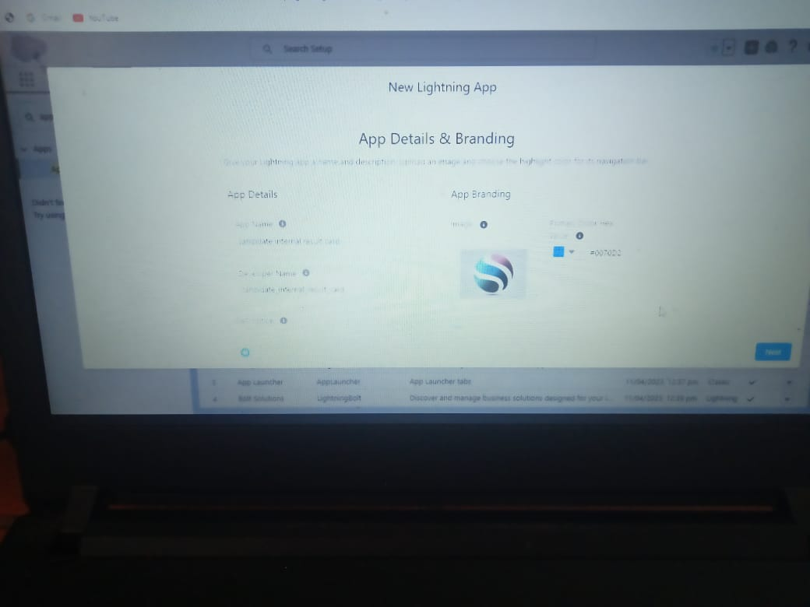

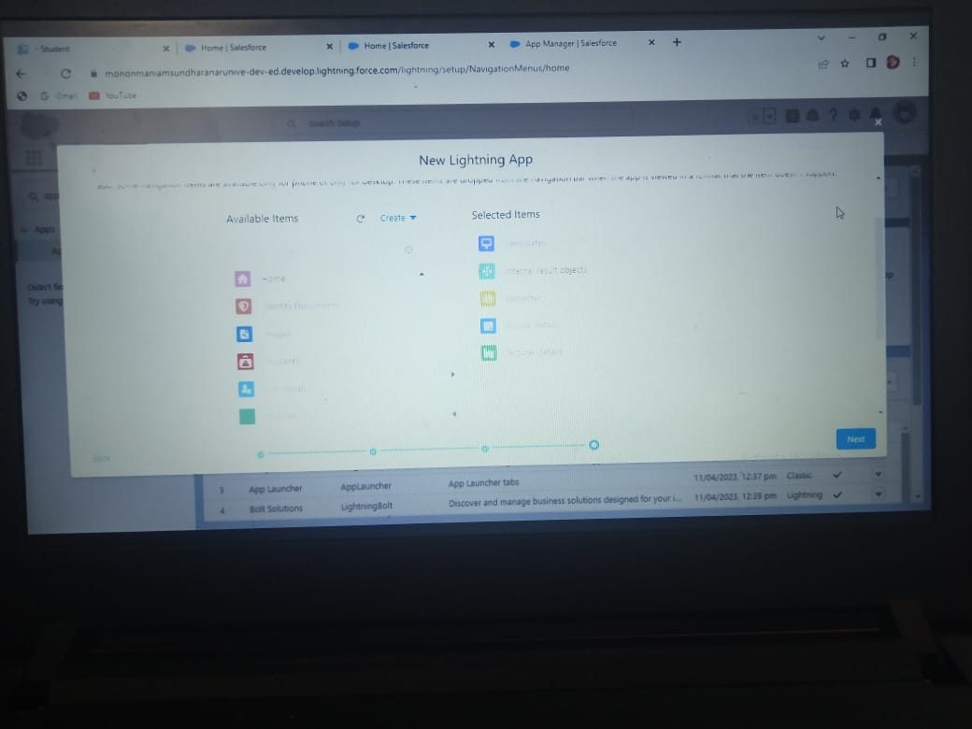

**Users**

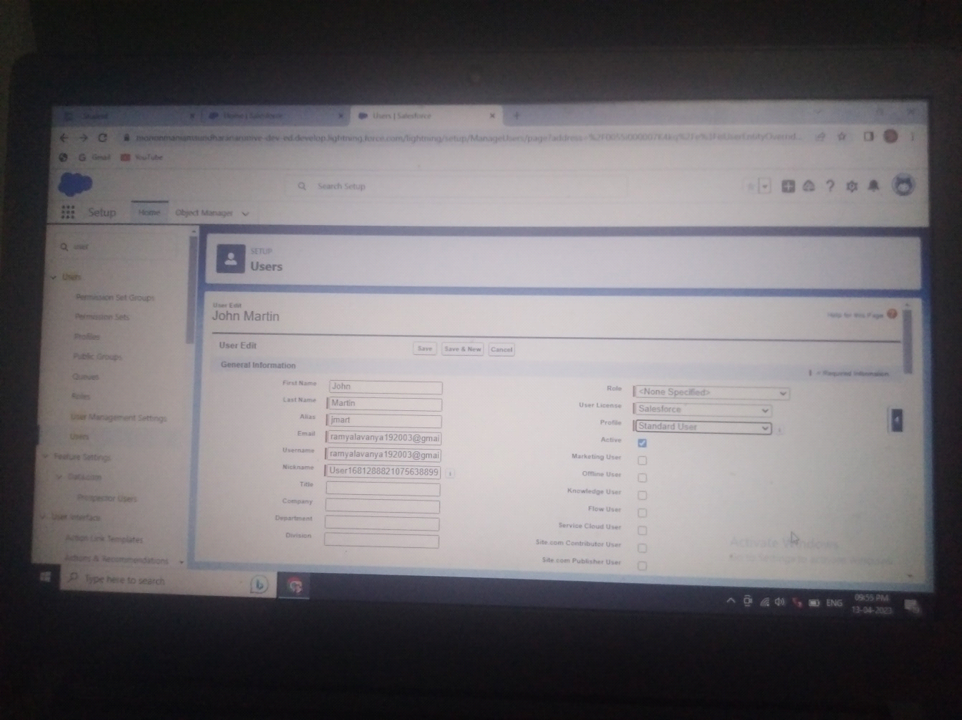

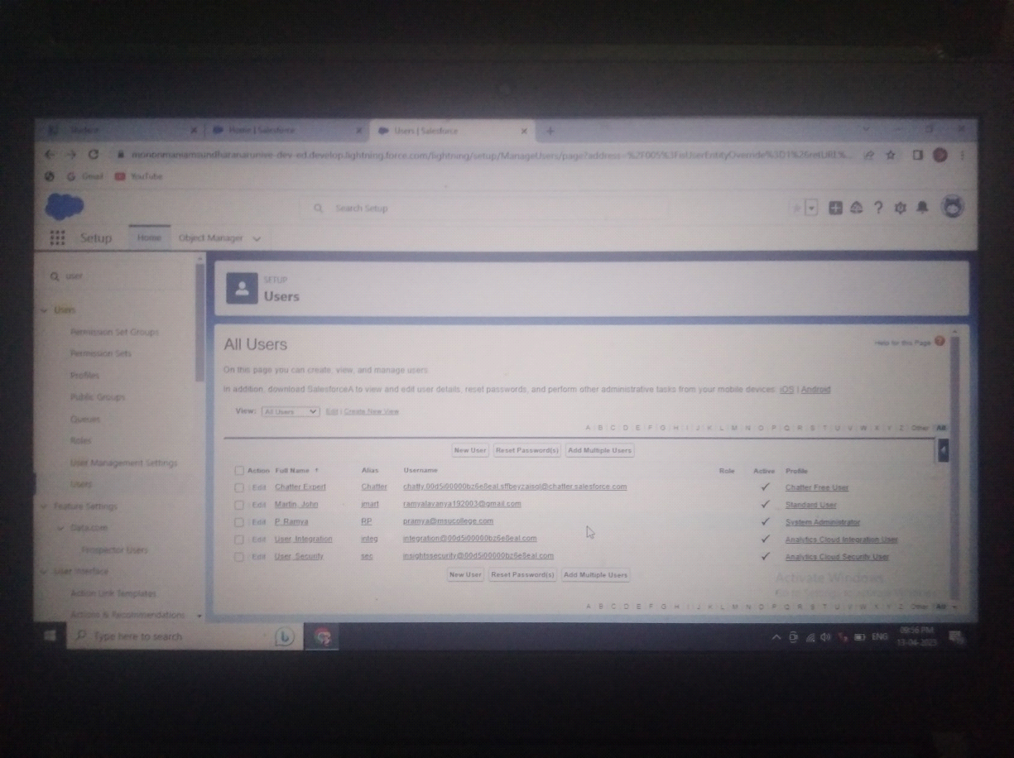

Reports

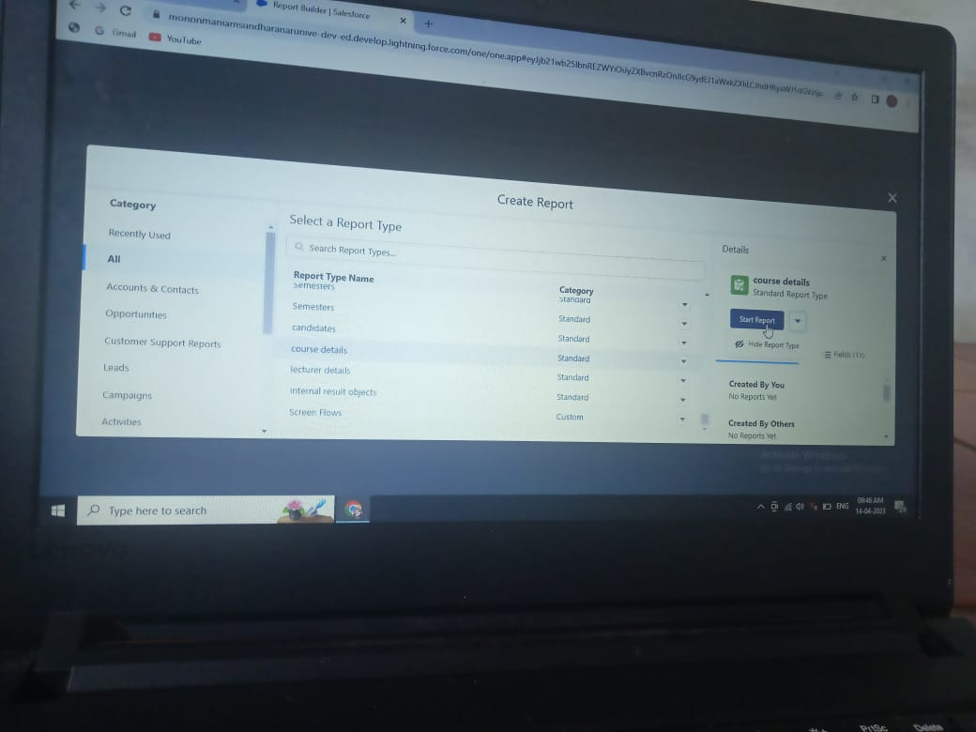

**TRAILHEAD PROFILE PUBLIC URL**

**Team Lead -** [**https://trailblazer.me/id/ramyp24**](https://trailblazer.me/id/ramyp24)

**Team member 1 -** [**https://trailblazer.me/id/vrajakumari**](https://trailblazer.me/id/vrajakumari)

**Team member 2 -** [**https://trailblazer.me/id/asasi40**](https://trailblazer.me/id/asasi40)

**Team member 3 -** [**https://trailblazer.me/id/csubethal**](https://trailblazer.me/id/csubethal)

**Team member 4 -** [**https://trailblazer.me/id/ssubhalakshmi**](https://trailblazer.me/id/ssubhalakshmi)

**ADVANTAGES**

* It allows for more effective sales and marketing.
* It can speed up the sales conversion process.
* It increases staff prodictivity, lowers time costs and boosts morale.
* It enables widely dispersed teams to work closely.
* Can improve customer loyalty through exceptional experience**.**

**DISADVANTAGE**

* Staff over-reliance on CRM may diminish customer loyalty through a bad experience.
* security concerns associated with centralised data.
* the excess initial time and productivity cost of implementation.
* it requires a process-driven sales organisation.
* it may not suit every business**.**

**APPLICATIONS**

Implementing CRM in results tracking can be used in all educational institutions to track candidate results.

It can be used both in schools and colleges.

In schools, college even universities, it would be very useful in monitoring students performance and records**.**

**CONCLUSION**

Educantional institutions deals with lots of test paper and student evaluation.

It is a painstaking process for teachers to evalute and keep track of student test and assessment.

So we have came up with a solution known as implementing CRM in result tracking with Internal Marks.

We have customized objects, fields and created Candidate Result card app in that app create reports and customized dashboard showing marks of student as vertical bars.

By this app we can show the students result in graphical representation which in casier to manage their results.

**FUTURE SCOPE**

**Omnichanel Dashboards**

Deeply integrates with social media. websites, cloud telephony and other software to bring all queries to a unified dashboards.

**Automations**

AL-powered bots, automated feedback or information form collection and canned responses save time for your staff.